Brian Davis

tug75085

915409443

10 April 2020

Homework 3: MapReduce

**For problems 1 and 2, I summarized the deliverables in the tables below. I extensively detailed (with screenshots) on all of my work to get these deliverables in pages 3 through 12.**

**The source code and reducer outputs can be found in /RawTextReducers/ and /RegularExpressionReducers/ for problems 1 and 2, respectively. Each folder has its own WordCount.java MapReduce program and it is thoroughly documented in this report how to execute these files.**

Problem 1: Word Count of *Pride and Prejudice*

|  |  |  |
| --- | --- | --- |
| Number of Unique Words | 5th to Last Word,  Number of Occurrences | 1st word,  Number of Occurrences |
| 13777 | yourselves, 1 | “’Tis, 2 |

Problem 2: Count Words with Letters in *Pride and Prejudice*

|  |  |  |
| --- | --- | --- |
| Number of Unique Words | 5th to Last Word,  Number of Occurrences | 1st word,  Number of Occurrences |
| 5999 | yours, 2 | A, 41 |

Problem 3

HDFS is a block-structured file system, which divides and stores files into blocks of predetermined size, usually 128MB. HDFS replicates each file across 3 DataNodes by default. Since there are only 3 DataNodes in this example, each DataNode will contain blocks A and B from sample.dat. The underlying process of DataNode replications commences when a client creates a file by calling create() on the distributed file system. The distributed file system will then make an RPC call to the NameNode to create a new file in the file system’s namespace, with 0 blocks initially assigned to it. The NameNode throws an IOException if it finds permission or file existence errors.

Upon successful file creation, a FSDataOutputStream is returned to the client for writing data. The data written by the client is divided into packets and placed in a data queue. The Data Streamer is responsible for asking the NameNode to allocate new blocks by picking a list of suitable DataNodes to store the replicas. DataNodes are chosen first for block A, then again for block B in this fashion. The NameNode will respond with the same 3 DataNodes each time since there are only 3 DataNodes in this HDFS.

The data streamer will stream the packets to the first DataNode in the pipeline. The DFSOutputStream will use an ack queue that is responsible for holding all of the packets that are waiting to be acknowledged by DataNodes in the pipeline. The client calls close on the stream when all file data has been written and all packets have been sent to the DataNodes. The NameNode then receives a message that the file writing process has completed. Thus, the file sample.dat will be successfully stored amongst the 3 DataNodes in blocks A and B.

Problem 5

In an instance of the Quorum Consensus algorithm with a group of 5 replicas, a read quorum of size $R$, and a write quorum of size $W$:

1. If $R=5$ and $W=1$, then the performance for writes is improved and the replica with the highest version number is guaranteed to be selected, however this increase in performance of writes comes at the cost of a decrease in performance of reads. Reads are generally more common than writes, therefore decreases in read performance will severely decrease runtime performance. Also, this allocation of quorums is not desirable because a read cannot occur if a single replica fails, given that there are 5 total replicas and a read quorum of size $R=5$. In addition, this allocation of quorums is not desirable because a write could occur on a single replica that fails, therefore forever losing the non-persistent state and content of the write. In order to avoid costly losses of information in the presence of replica failure, a write quorum of size $W>1$ is preferred.
2. If $R=1$ and $W=5$, then the performance for reads is improved and all replicas are guaranteed to have the highest version number, however this increase in performance of reads comes at the cost of a decrease in performance of writes. Reads are generally more common than writes, therefore increases in read performance will severely increase runtime performance. However, this allocation of quorums is not desirable because a write cannot occur if a single replica fails, given that there are 5 total replicas and a write quorum of size $W=5$. In order to avoid costly losses of information in the presence of replica failure, a write quorum of size less than the total number of replicas is preferred.
3. If $R=3$ and $W=3$, then the performance for reads is balanced with the performance for writes. Reads are generally more common than writes, therefore increases in read performance will severely increase runtime performance. However, this allocation of quorums is desirable because it decreases the performance for reads in order to provide reasonable availability for writes. Since the size of readers and size writers are both greater than half of the number of quorums, then reads are guaranteed to have the highest version number. This tradeoff is also necessary in order to ensure availability through replica failures. Even if 2 out of 5 replicas fail, the consensus algorithm will prevail, which makes this network robust to failures. In comparison to the $R=1$ and $W=5$ option above, this allocation of quorums is superior because it only decreases the read performance by the addition of 2 replicas, while increasing the write performance by the subtraction of 2 replicas and ensuring availability through 2 replica failures. In comparison to the $R=5$ and $W=1$ option above, this allocation of quorums is superior because it only decreases the write performance by the addition of 2 replicas, while increasing the read performance by the subtraction of 2 replicas and ensuring availability through 2 replica failures.

**EC2 Creation**

First, I chose the AMI type Ubuntu Server because I was able to find success setting up Hadoop on a local virtual machine running Ubuntu previously. The AMI type is seen below,



Next, I chose the instance type t2.large, which has 8 GiB of memory, in comparison to 2 GiB on the t2.micro. This is necessary in order to ensure Hadoop and MapReduce can run smoothly, as I had limited memory issues on my local environment previously. The instance type is seen below,

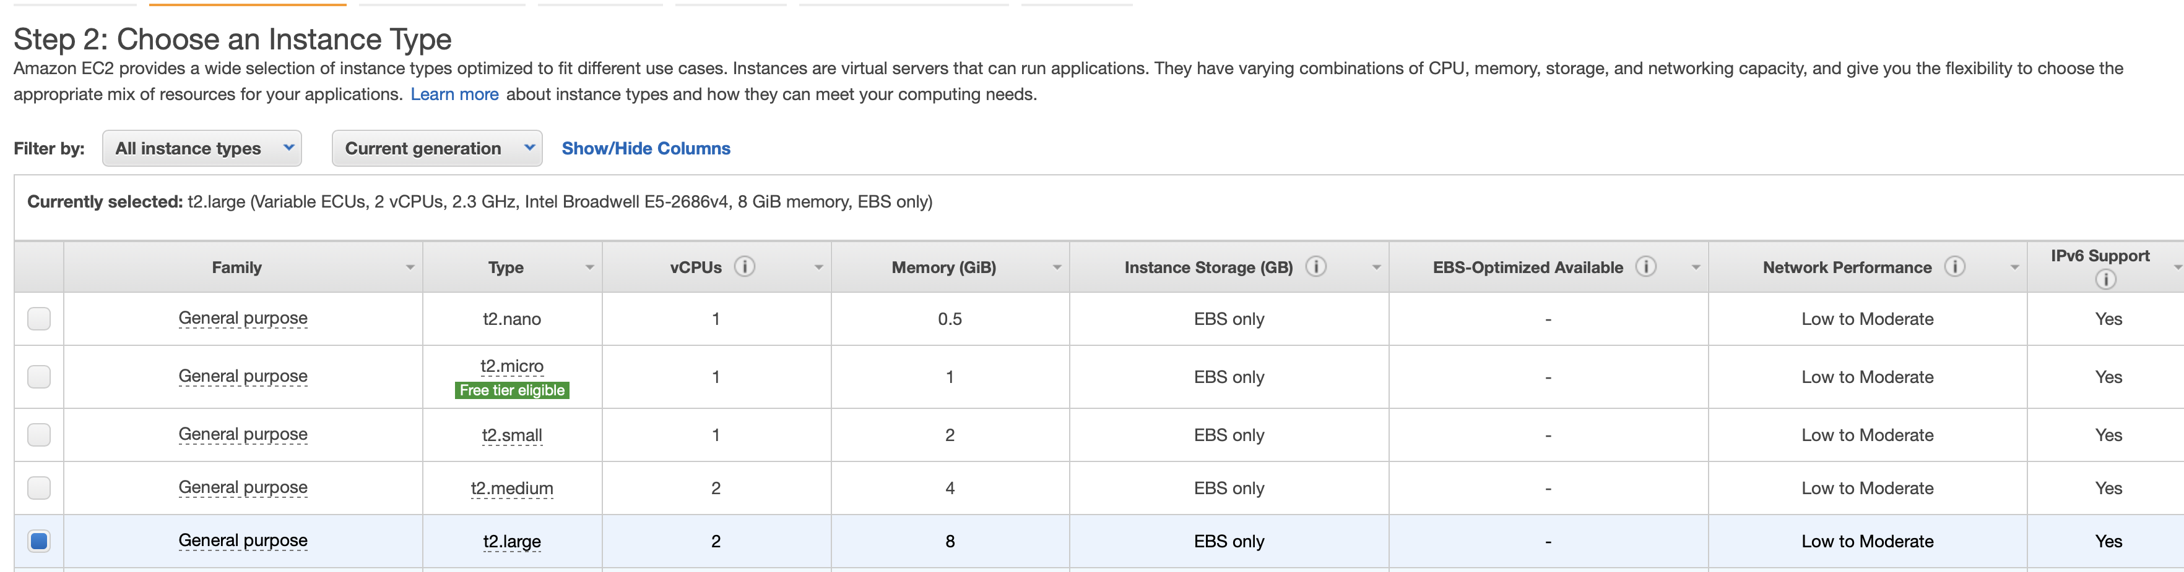

I created an IAM Role that allows Administrator Access to all AWS services, as seen below,

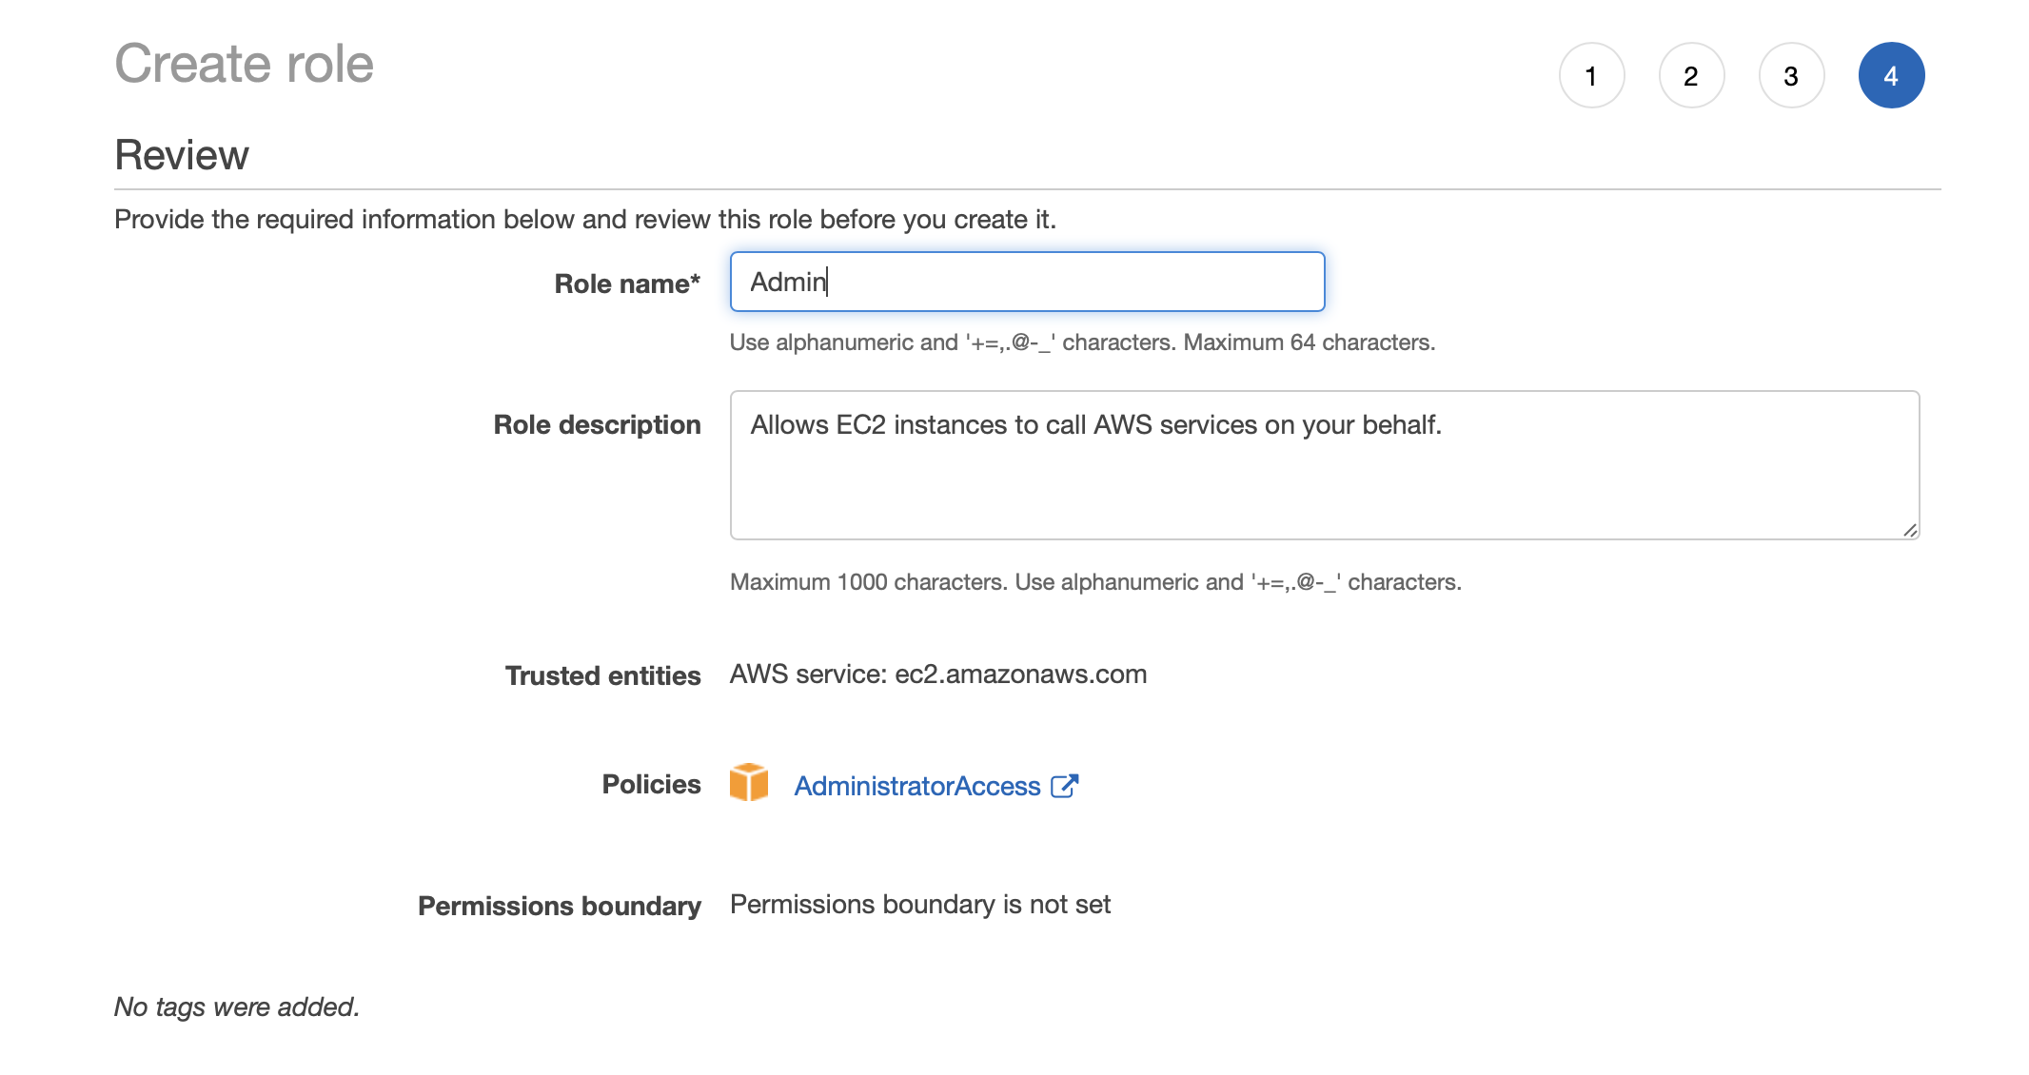

In the Configure Instances tab of the EC2 creation, I selected Administrator Access to all AWS services and to protect against accidental termination, as shown below,

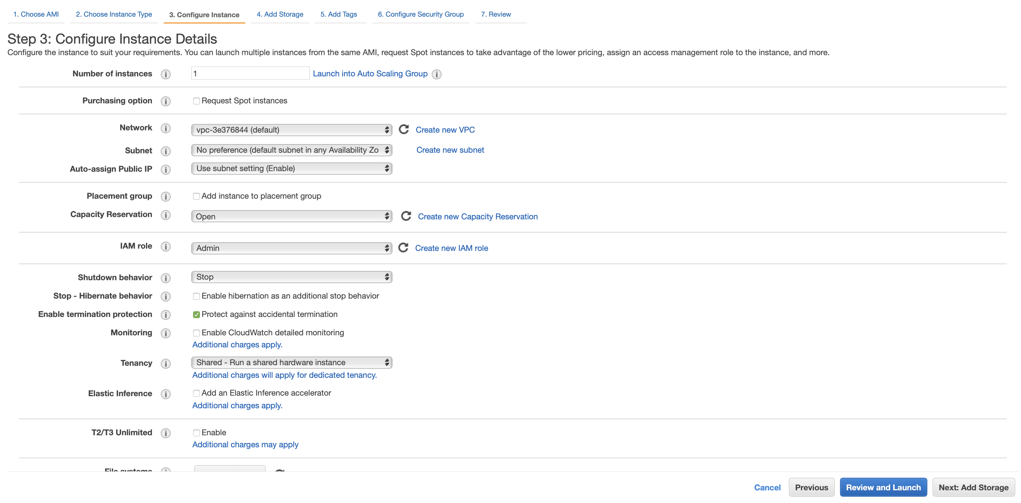

In the Configure Security Group tab of the EC2 creation, I selected all ICMP and TCP ports so that the Hadoop webserver can work properly with limited flaws, as seen below,

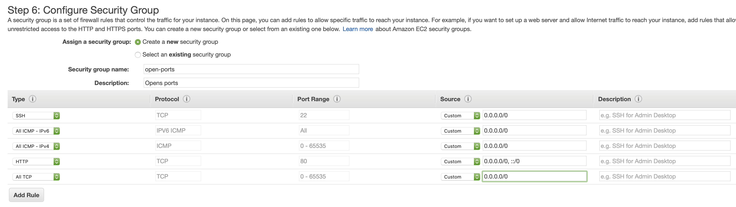

**Setting up Hadoop on Ubuntu EC2 Instance**

First, we must install Java and Hadoop. We gather the tar files and untar them as seen below,



First, we have to set environment variables in the ~/.bashrc, as seen below,

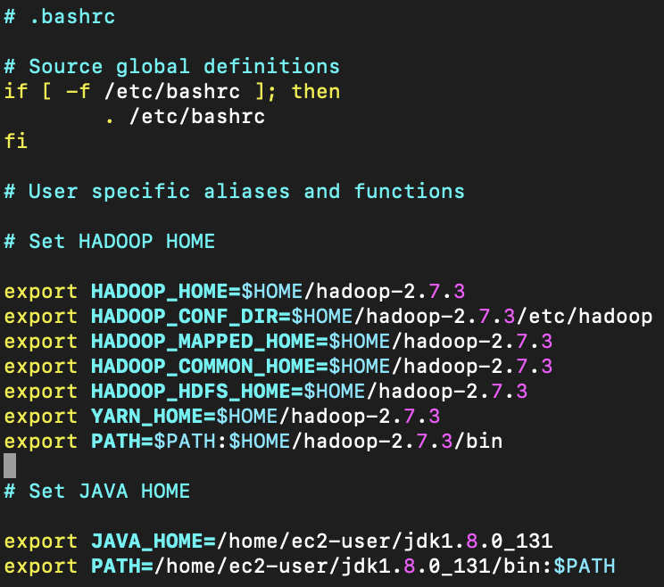

Next we activate the environment,



Then we ensure that ssh permissions for localhost are authorized,

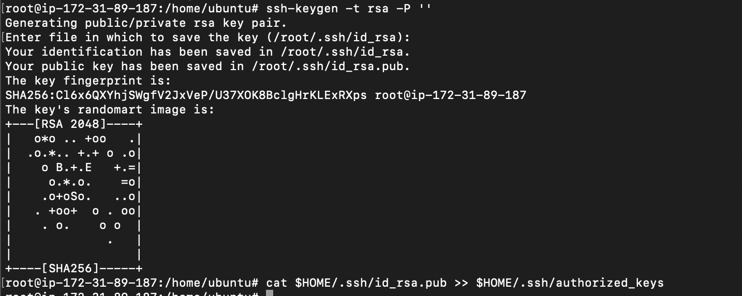

Example of ssh-ing into localhost

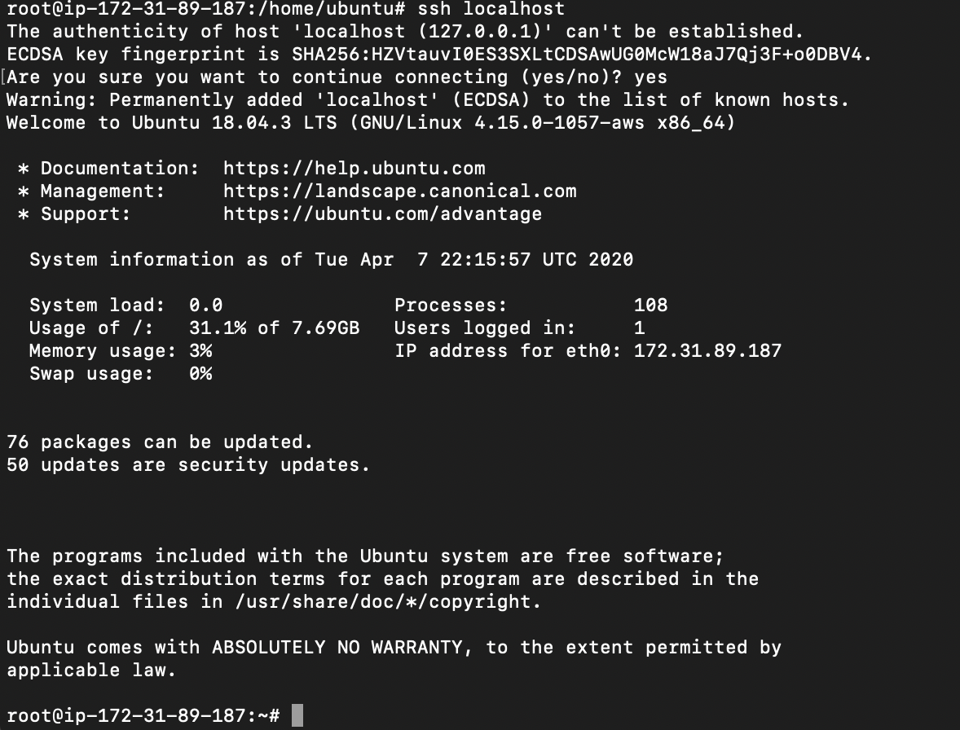

Logging out from localhost



Next, we add specifications to the XML files for the Hadoop file system. This includes for running the dfs, as well as yarn.

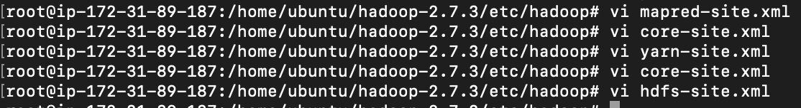

Next, we format the Hadoop filesystem,

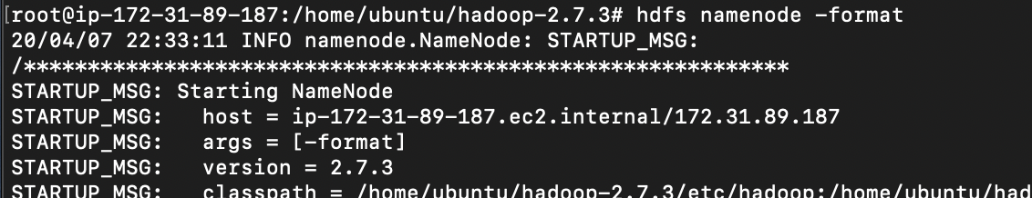

Starting the NameNode, DataNode, SecondaryNameNode, and ResourceManager,

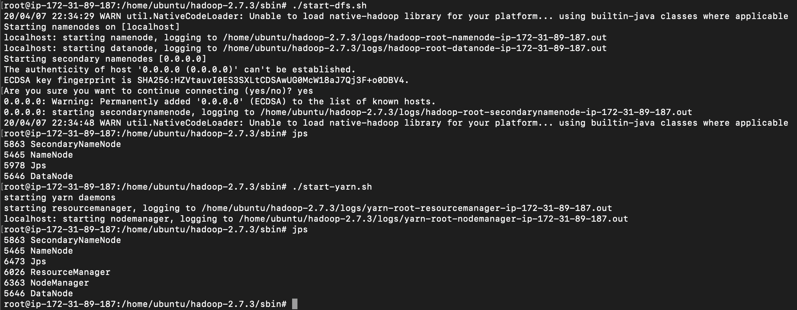

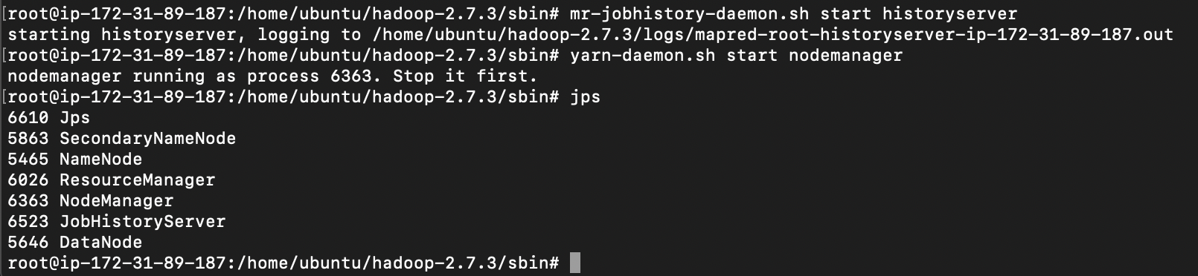

Viewing the website that displays the Hadoop file system

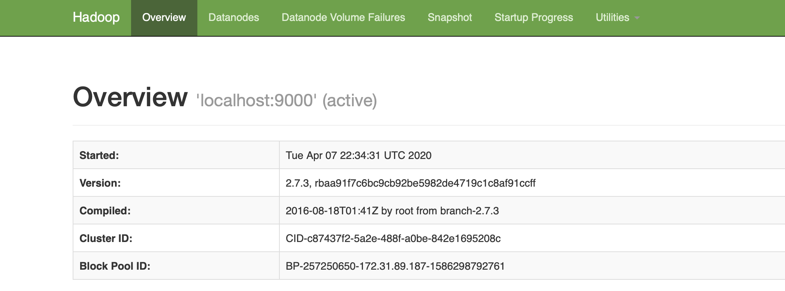

Making the input directory and copying the *Pride and Prejudice* text file to the Hadoop file system.

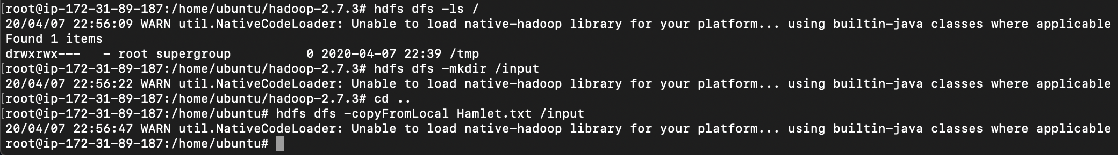

**MapReduce Modifications**

Modifying the Mapper of the WordCount.java script in order to suit our needs to count only words with letters. The regex expression “^[a-zA-Z]+$” ensures that only non-null strings with alphabetic characters are passed to the mapper. I used Java’s Pattern class to compile the regex expression and Java’s Matcher classes to identify matches in the strings tokens.

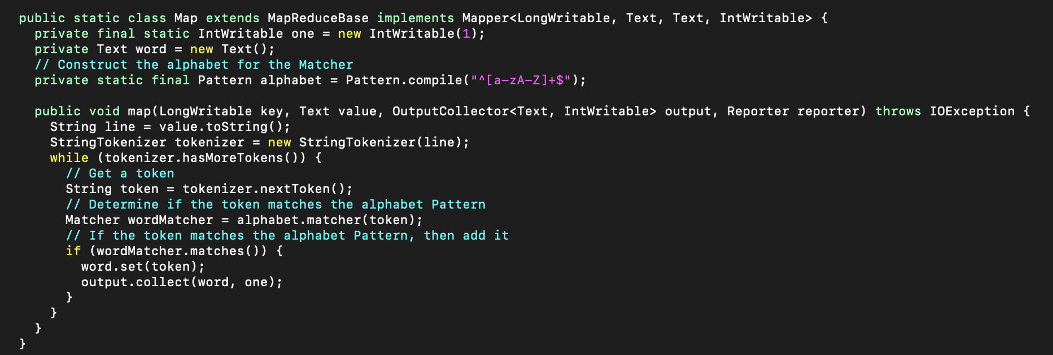

In addition, I set the number of reducers to 5 programmatically for our tests, as seen below,

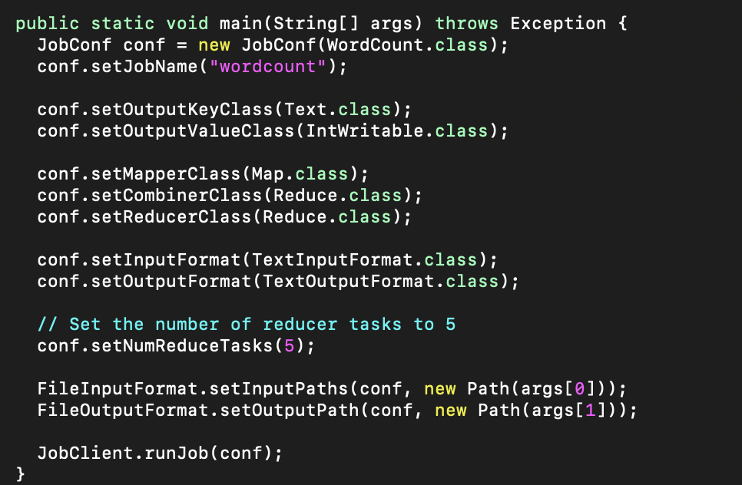

The main portion of this program is counting the unique words from the *Pride and Prejudice* text file. In order to do this, we need to first compile out MapReduce program so that it can be run on Hadoop. Below, we can see the compilation of the WordCount.java MapReduce program, and the subsequent compilation of the WordCount classes into WordCount.jar, all seen below,

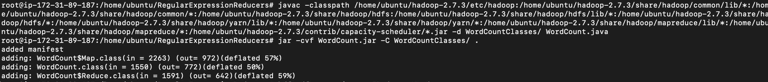

Next, we run the WordCount.jar on the Hadoop file system, as seen below,

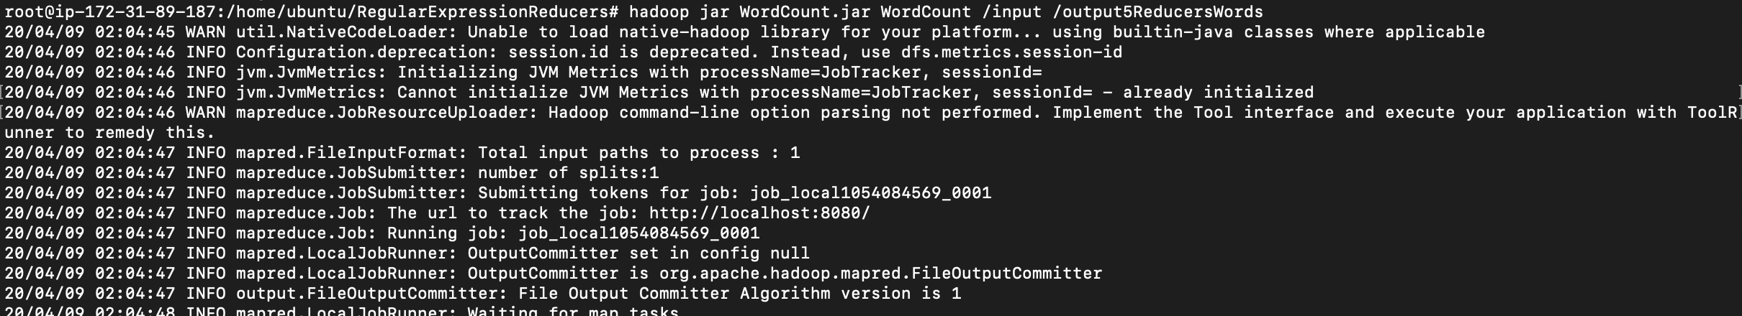

We were able to map and reduce the program!



We can see the 5 output files in the Hadoop file system on the website, as seen below,

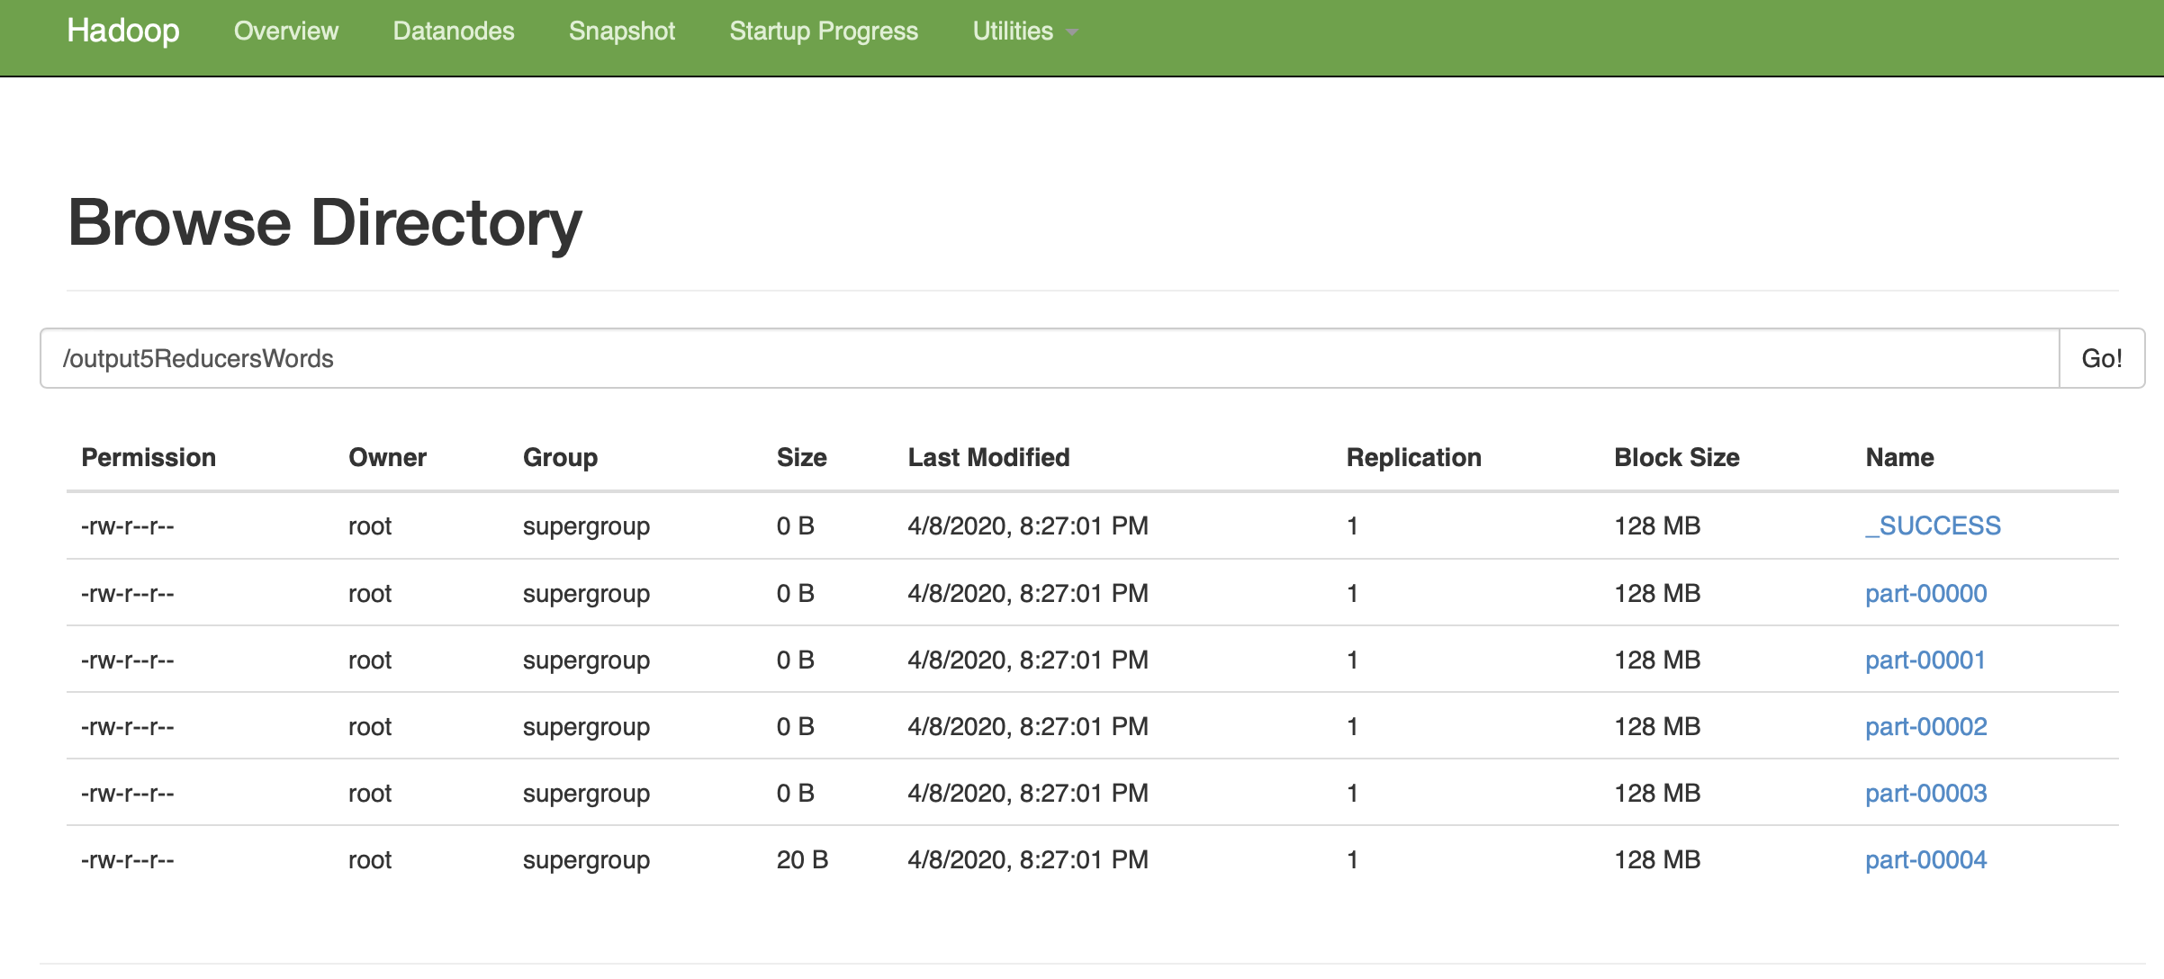

Next we get the output from the 5 reducers and store it locally, as seen below,



**Obtaining the Deliverables**

I wrote a bash script to determine the unique word count, the fifth to last word and its number of occurrences, and the first word and its number of occurrences, as seen below. The 5 output files from the reducers are all in the output5ReducersWords directory. This bash script concatenates them and pipes them into their respective functions.

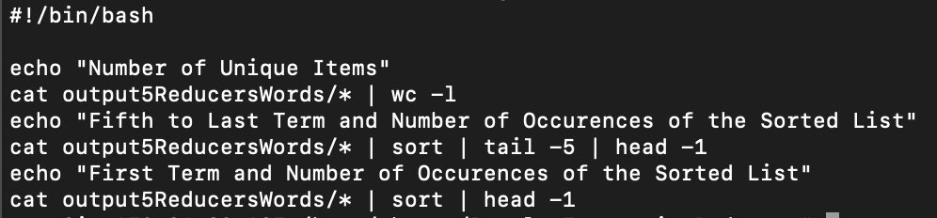

When we run the bash script, it determines the unique word count, the fifth to last word and its number of occurrences, and the first word and its number of occurrences, as seen below,

When we use all text in *Pride and Prejudice*, the answers are,

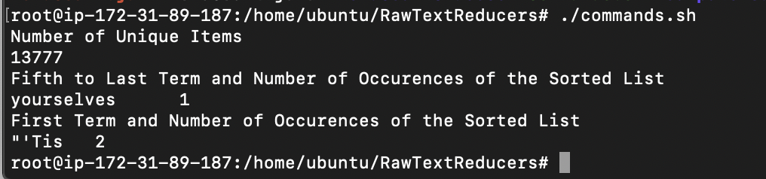

When we only map and reduce the words in *Pride and Prejudice*, the answers are

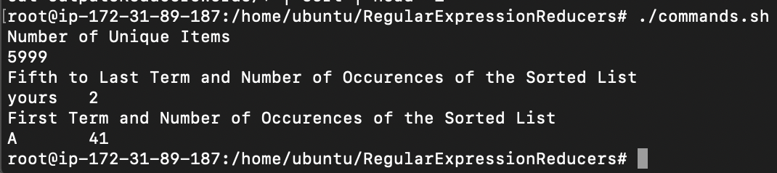

Finally, we are done and we can stop the Hadoop filesystem,

